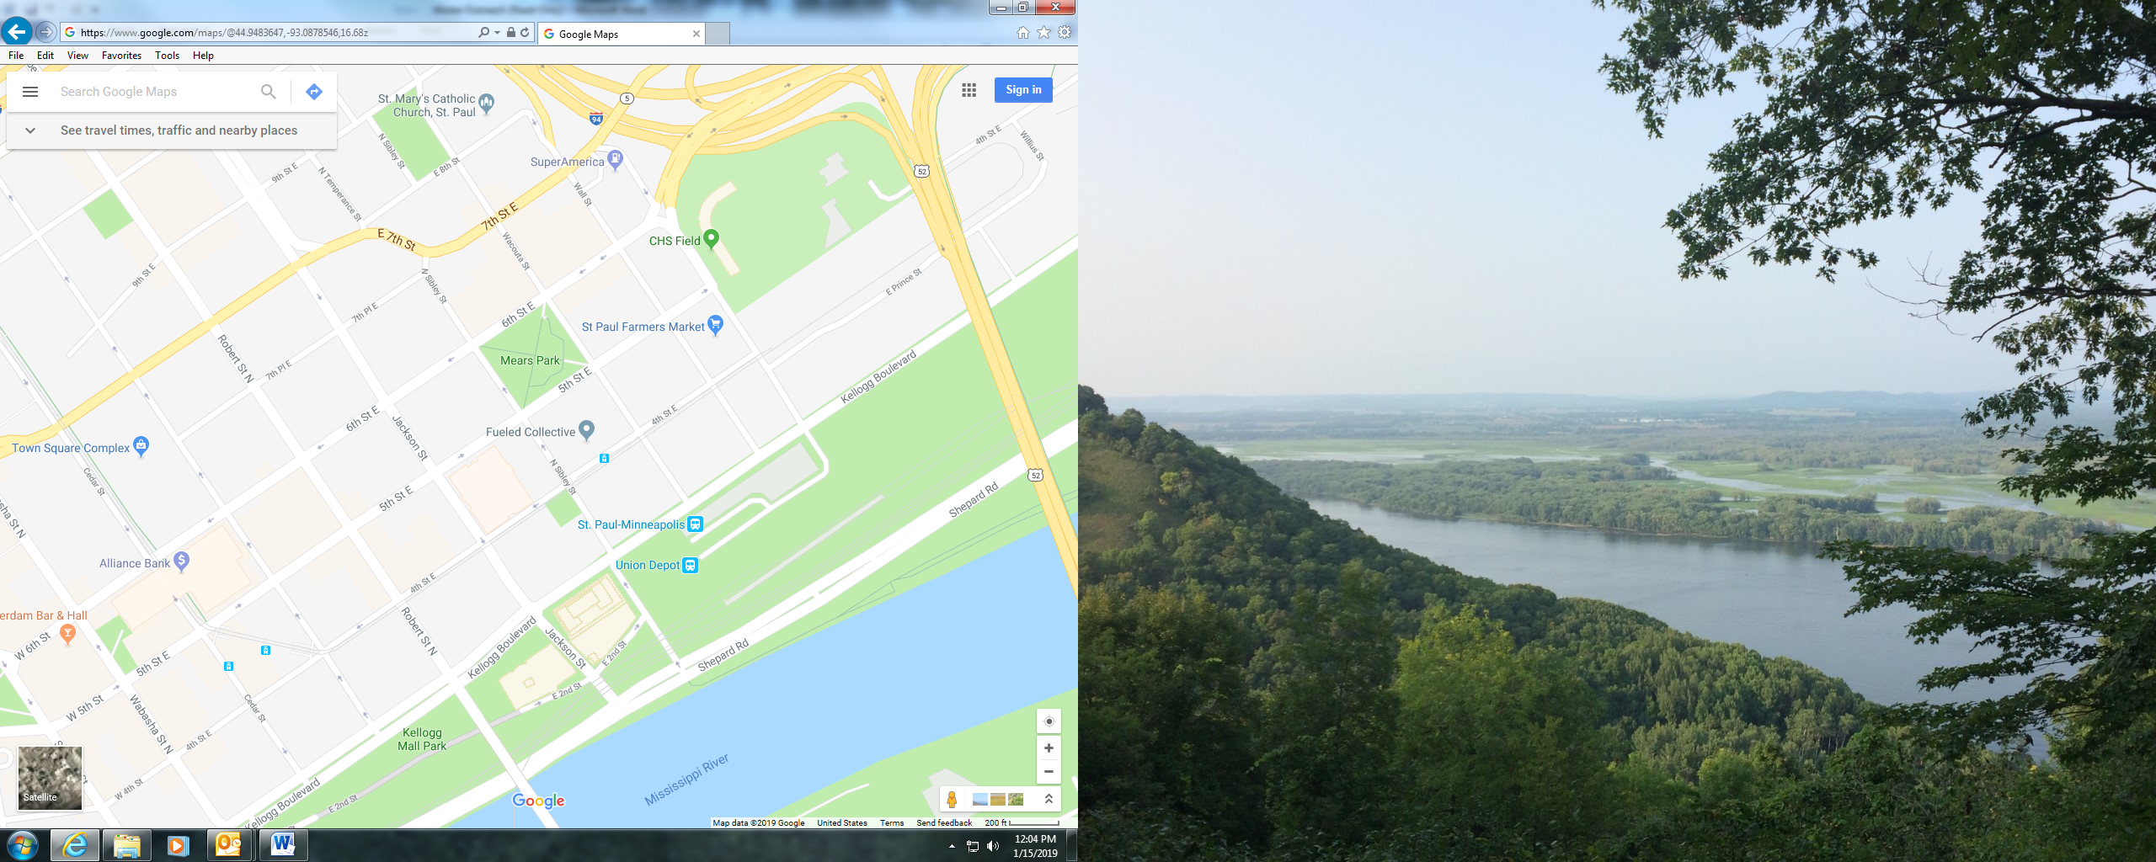

**Torchlight Parade February 2, 2019**

Staging: 3:30pm Parade Start: 5:30pm

Green= staging Purple = parade

Blue= Dispersal/disassembly

=Volunteers Red=Vulcan Line-up

Parades end at Kellogg and Minnesota St.

If *NO DISASSEMBLY* needed – drive straight on Kellogg towards Robert

If *DISASSEMBLY NEEDED* – take a left on Minnesota St. and break down there; may need to wait for a break in the parade going down 5th St.

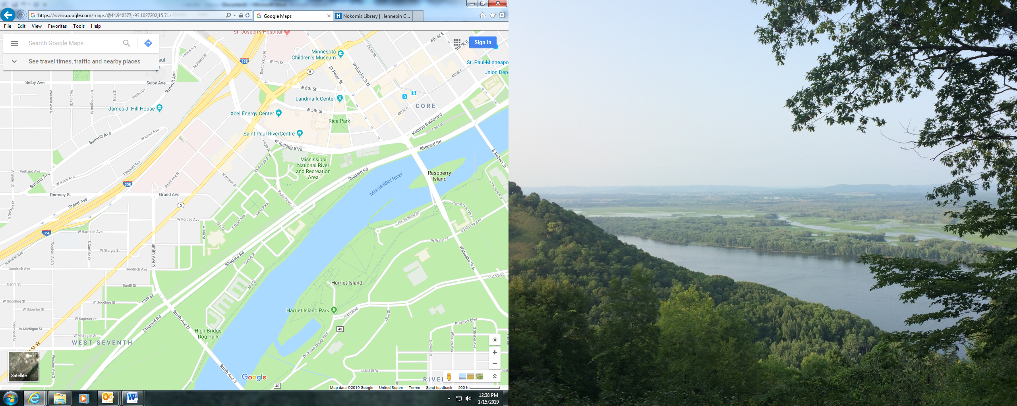

West 7th St.

Cedar St.

Minnesota St.

**Grand Day Parade January 26, 2019**

Staging: 12:00pm Parade Start: 2:00pm

Green= staging Purple = parade

Blue= Dispersal/disassembly

=Volunteers =Visiting Queens

Parades end at Kellogg and Minnesota St.

If *NO DISASSEMBLY* needed- continue down Kellogg towards Robert

If *DISASSEMBLY NEEDED*- turn left on Minnesota St. between Kellogg and 5th St.; beware of Light Rail