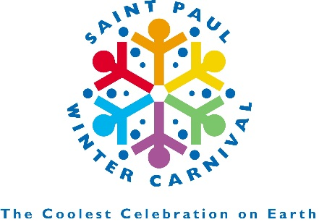

**Saint Paul Festival and Heritage Foundation**

**429 Landmark Center, 75 W 5th Street**

**Saint Paul, MN 55102**

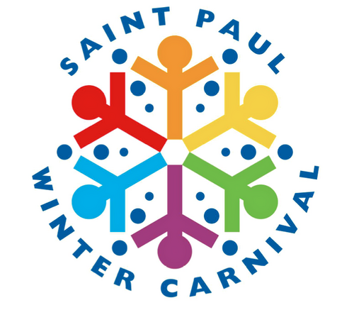**2017 WAIVER AGREEMENT**

I, the undersigned, have agreed for my own benefit to participate in various events and activities held during the year(s) 2016 – 2017 in connection with and/or under the direction of the Saint Paul Festival and Heritage Foundation.

I understand that inherent in my participation in such events and activities, such events to include without limitation, parades, is the risk of serious personal injury and property damage. I understand that the Saint Paul Festival and Heritage Foundation will not provide me with protection against such injury and damage, and I assume all risk of such injury and damage to myself and all other under my direction and control, and to my property and all other property under my direction and control. I hereby waive and release any claim I have or may have in the future against the Saint Paul Festival and Heritage Foundation and any of their officers, directors, employees, agents and volunteers, for any personal injury, property damage or other damage I may sustain, whether or not caused in whole or in part by the negligence of such officers, directors, employees, agents and volunteers, which occurs during or as a result of my participation in any of the events and activities held in connection and/or under the direction of the above-referenced entities. Furthermore, in the event I agree to operate a vehicle in connection with any of the events and activities held in connection with and/or under the direction of the Saint Paul Festival and Heritage Foundation, I represent that I am validly licensed to drive such vehicle in the events and/or activities and that I have purchased automobile insurance as required by Minnesota law, and that I am responsible for complying with all laws that apply to me as a driver of a vehicle.

I also agree to obey by the rules put forth by the Parade Committee of the Saint Paul Festival and Heritage Foundation, including (but not limited to) abstaining from throwing candy or other items from parade units and the consumption of alcohol during lineup, on parade unit or along parade route.

___________________________ ____________________________________

Date Signature

____________________________________

Signature of Parent or Guardian (if under 18)

____________________________________**_**__________________________________

Name of Unit or Organization

**All participants**, including unit drivers, float personnel, members of novelty units, and riders and drivers of horse units, **must sign and submit** this form to the Saint Paul Festival and Heritage Foundation prior to the event specified. Organizations must make additional copies of this form for signature by each participant.