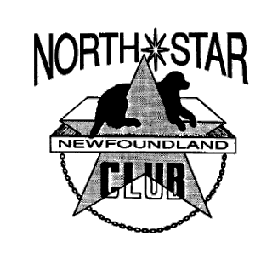**Northstar Newfoundland Club**

**Part of the Newfoundland Club of America Rescue Network Application Form**

You have expressed an interest in acquiring a Newfoundland dog, which will be placed by the NCA Newf Rescue Service according to the conditions set forth in the Placement Agreement. Please answer the following questions and return this Application Form to: **ticklebaynewfs@yahoo.com**

1) Why do you want a Newfoundland dog?

2) Have you ever owned a Newfoundland dog? If you no longer own the dog, please explain.

3) Do you currently have another dog(s)? What breed, sex, age, neutered? Any other pets?

4) How many people live in your household? Children and their ages?

5) Do you prefer a male or female dog? Why?

6) Please describe in detail the area where the dog’s primary living space would be.

7) Please describe your yard. List size, fence type if any, and any other notable characteristics such as a kennel or pond.

8) How many hours per day will your dog spend alone at home?

9) Does anyone in your household have ANY objections to adding a dog to your family?

10) Using a scale of 1 – 10, with 1 being fairly inactive and 10 being very active, describe your family’s activity level.

11) List some activities that your family engages in on a regular basis (please consider summer and winter, indoors and outdoors).

Your Name:

Address:

Email Address:

Phone:

Date:

This Application and your Placement Agreement will be held by the regional representative who serves Newfoundlands in your area. At the time that a Newfoundland becomes available all such Applications and Placement Agreements so held will be reviewed and the dog will be made available to the home that most closely matches the individual dog’s needs in the eyes of the NCA representative. Because of the uncertainty surrounding the availability of dogs and the many determining factors for placement we do not give any guarantee as to how long it will take to find any individual home a dog.